**Goal**

Create trade specific smartsheets to further simplify the process of presenting subcontractors with vital information for coordination.

**Steps**

1. Create master smartsheet containing information for entire project.

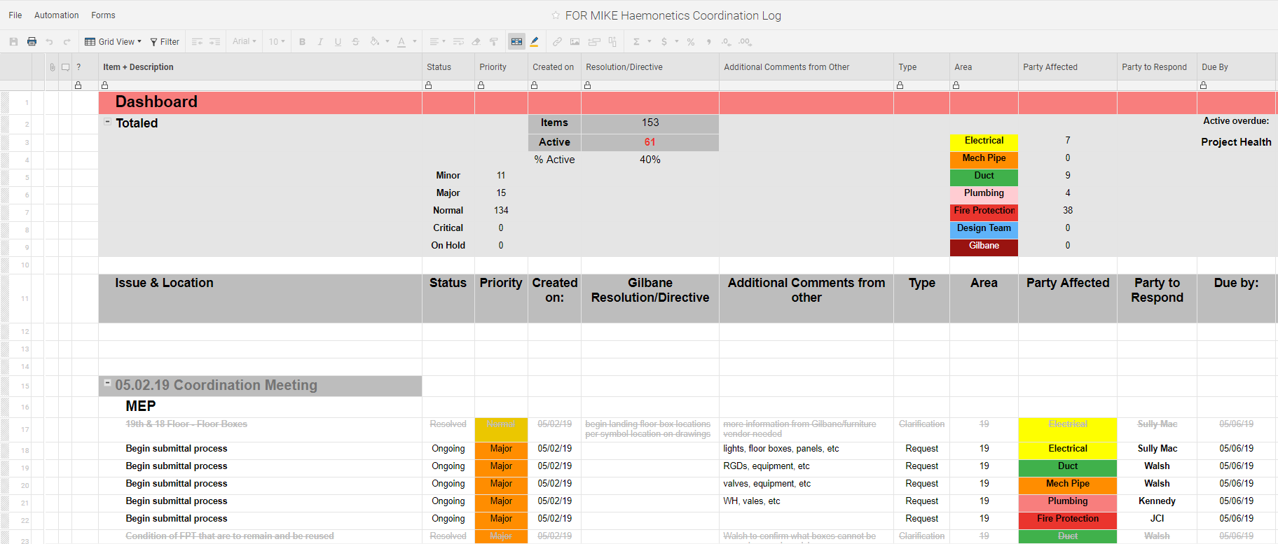

1. The smartsheet should have a section dedicated to the affected trade or area. This naming system should be uniform for each entry. This means use the same word for a trade every time. Do not use multiple names like “ELEC” and “Electrical” or even “elec”.
   1. Keeping the naming system very uniform will make it much easier to pull the information you want into a report.
2. Create new reports for every trade. I suggest keeping these reports in a folder dedicated to your project.
3. After creating a new report and opening it, you will be prompted with the “Report Builder”

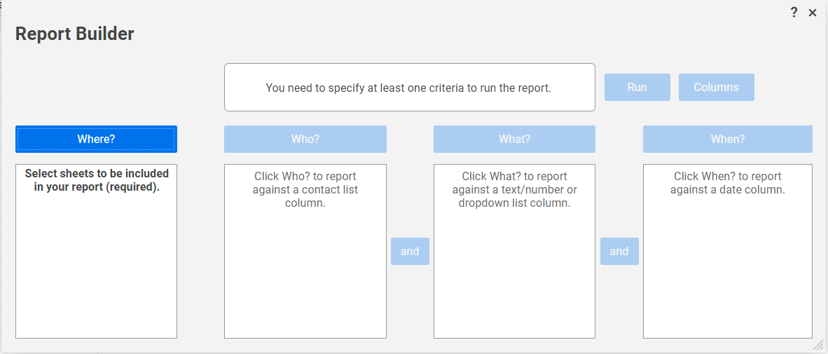

1. The “Where?” section allows you to choose what sheet(s) you want to pull from. The “Who?” section lets you pull information based on who created the information, this section is optional. The “What?” section is where you choose what column to pull information from. Then you choose what information to pull down from the master sheet.

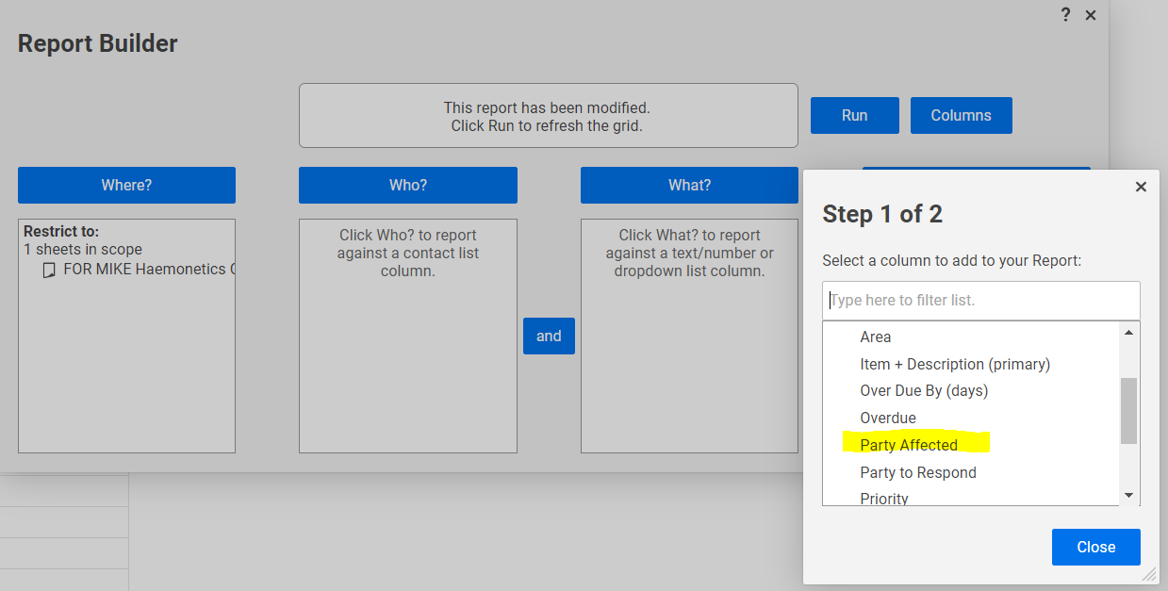

In this example, the trades were identified in a column called “Party Affected”.

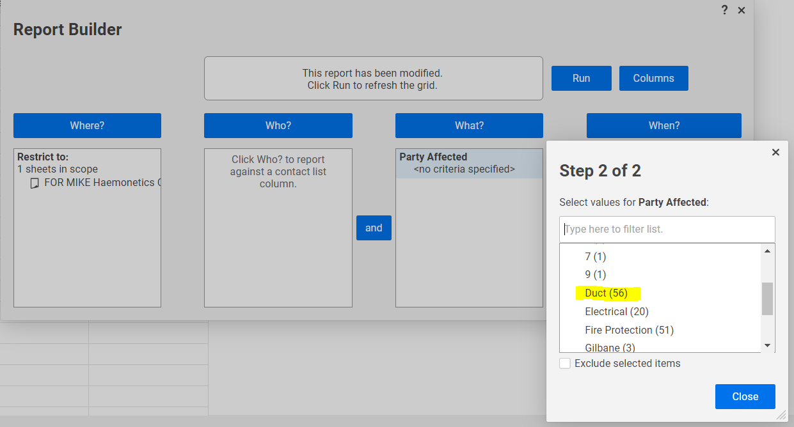

The specific trade that this example report is for is ductwork. This report would be published to whatever subcontractor is responsible for all the ductwork.

1. The “When?” section can be used to only pull information from a specific time. This would be useful if you wanted to give a subcontractor a report of only the items from the last week. For this example, it is not used, but it could be very useful for presenting trades with time specific information.
2. The final step in creating the report is to select what columns you want to include. Just click on the “Columns” button and select what columns you want in the report. The columns are added to the report based on the order that you selected them. So, if you want your report to be the same format as your master sheet, you have to select the columns in the same order.

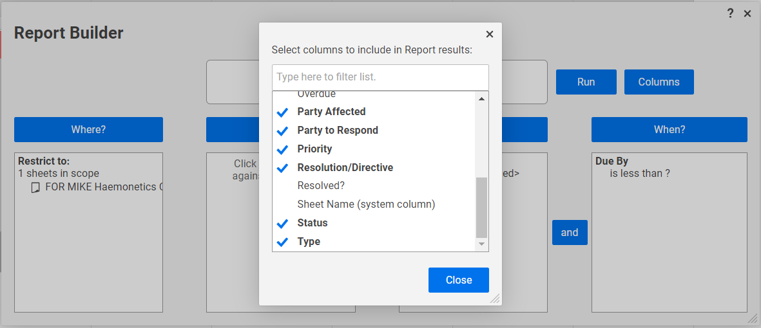

1. After all your columns are selected, click “Run”
2. This should produce a report of all the rows that pertain to the trade you selected. For this example, a report for all rows containing information on ductwork.

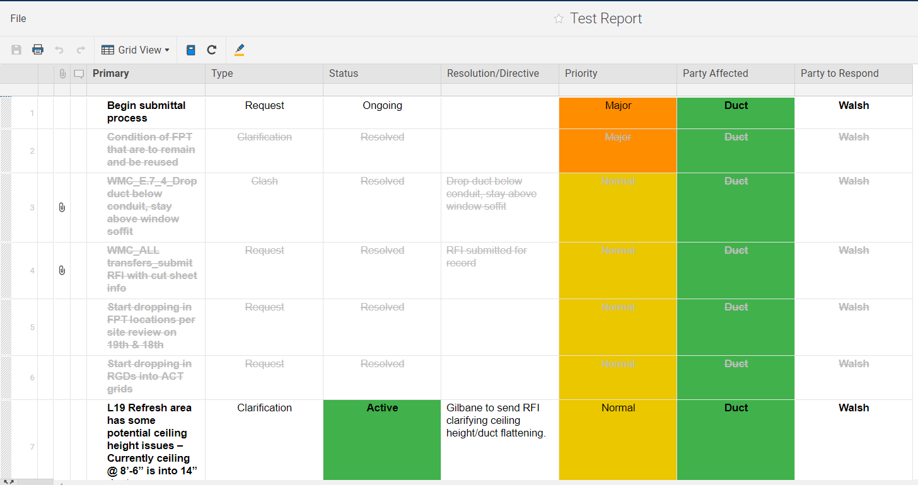

* 1. After a report is created, the easiest way to share it is to publish it. This produces a link so that anyone can view the report, even if they do not have a smartsheet account.

1. To publish a report, click on the globe icon on the right-hand side of the screen

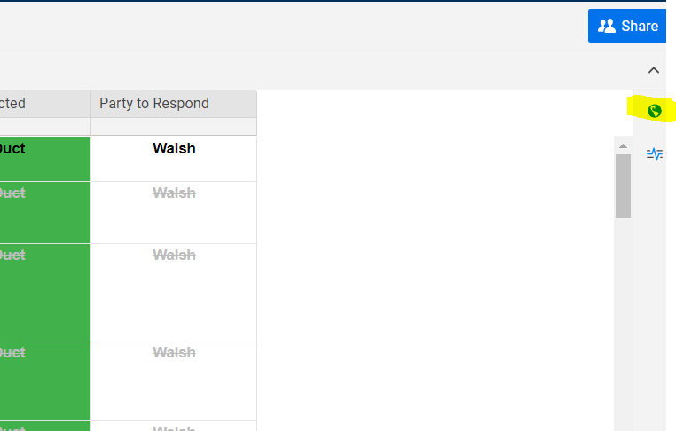

1. Clicking on the globe icon will bring up a pop up, click the slider to produce a link to the report.
2. Copy the link provided, you do not need to change any of the other settings.

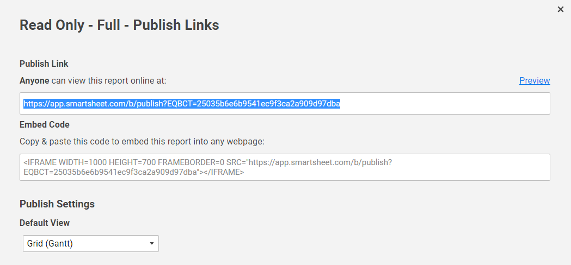

1. This link will allow anyone to view the report and gives them the ability to view and download attachments.